**DOWNTOWN HISTORIC DISTRICT**

Leavenworth’s 45-block downtown was planned in 1854, and in its first two decades, commerce boomed. Most of the City’s early stores were built in “blocks” with multiple storefronts and common upper areas. Many of these magnificent structures are gone and some that remain are the lower floors left after fire, tornado and neglect took their toll on the upper levels. Infill is evident nearly everywhere and pavement replaced buildings as the demand for off street parking grew, especially after World War II. Examples of block-style development still evident today are the O’Donnell Block at 100 South 5th Street, the Masonic Temple at 421 Delaware, the Yum block at 311-321 South 5th Street, and the intact block of commercial stores in the 600 block of Cherokee Street.

There are 65 contributing properties in the district, mostly constructed of red brick with cast iron and terra cotta trim features. Their architecture is described as “high style” with Colonia and Classical revival variations reflective of their era. Two were previously placed on the national register of Historic Places. (429 and 500 Delaware Street).

**KNIGHTS OF COLUMBUS BLOCK**

**331 DELAWARE STREET, c. 1882 c. 1945**

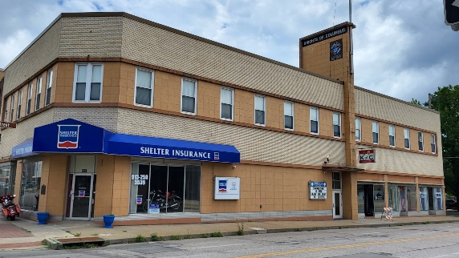

This three-story building has a corner entrance that is canted at both stories. The façade of this late 19th century building was significantly altered I the 20th century. Divisions are created with brick stringcourses and by alternating different color of brick and large, cast stone tiles. Commercial storefronts occupy the first story and are divided into three bays on the Delaware Street façade. The c 1945 alterations have achieved their own significance as a historic alteration and maintained the size, scale and mass of the original building.

**McCAFFREE SHORT TITLE CO.**

**330 DELAWARE STREET, c. 1910**

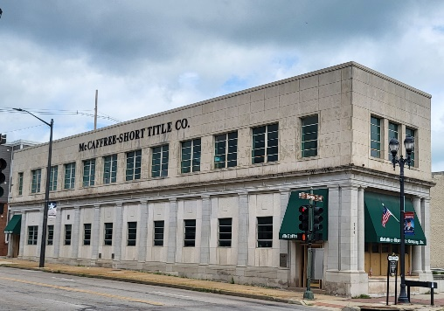

This two-story building is a streamlined adaptation of the Neoclassical Revival style, one bay wide and 12 bays long. Round inner columns and square outer corner columns flank each window and support a simple frieze and cornice. The building terminates without ornamentation. The west façade of the building has 12 bays separated by simple pilasters that support a frieze and cornice. Much of the building’s original fabric is intact and in place and retrains a high degree of integrity. An original third story was removed after being damaged by a tornado.

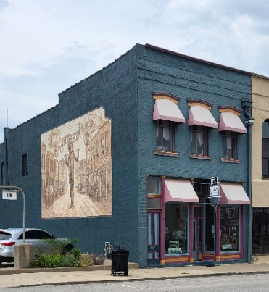**FIRST CITY PHOTO**

**406 SHAWNEE STREET, c. 1865**

The first story of the redbrick structure has four bays and an end (west) bay entrance to the second story. Display windows flank a recessed entrance. All of the original storefront treatments are intact, including the cast-iron bulkheads, transoms, and window enclosures. The second story has three bays. Above the second-story windows and at the roofline, narrow, brick stringcourses project slightly from the building. In 2003, a mural of early Leavenworth and native son Buffalo Bill Cody was painted on the west elevation.

**LEAVENWORTH CITY HALL**

**100 NORTH FIFTH STREET, c. 1924**

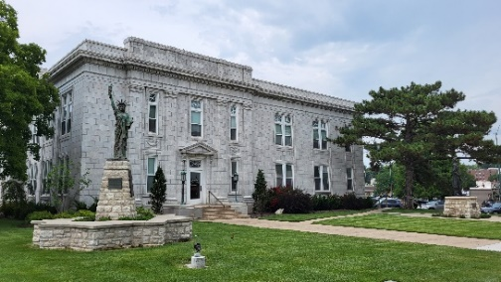

Leavenworth’s City Hall is a detached, two-story, light gray terra cotta building on a landscaped area on the west half of Block 50. Feth & Feth, local architects, designed this and many other city halls, courthouses and schools in the greater Kansas City area. This building is an excellent example of the Classical Revival architectural style favored by private and public institutions during the early 20th century. A classical entablature wraps around the building. Over the entrances and above the entablature are parapets clad in terra cotta. The spandrels on both elevations have classical garlands in low relief. In 2004, all covered windows were reopened and an interior light court was reopened as a significant architectural feature.

**O’DONNELL BLOCK**

**100-108 S FIFTH STREET & 501-505 SHAWNEE**

**1905 (WITH PARTS DATING TO 1854)**

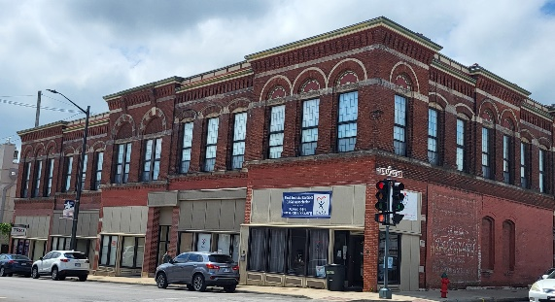 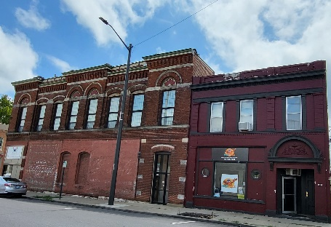

**100-108 S 5th Street 501-505 Shawnee Street**

This two-story brick building had deteriorated during the 1970’s through the 1990s and was scheduled for demolition. In the 1990s, it was rehabilitated as an early example of a mixed use (commercial-residential) success. During the interior tear out, it was apparent that most of the foundation was original to a building build at this location in 1854, making at least a part of this building once of the earliest in town. The east elevation has five separate storefronts that feature full arches that span the width of the paired windows and rise to the roofline. Within the arches is a terra cotta sunburst. A common element in all of the sections is the use of stone belt-courses to visually separate the first and second stories. Brickwork, laid in a textured pattern, defines the entablature and projecting cornice of the different building segments. Other common stylistic elements are cornice window heads, architrave window frames, and stone sills supported by brick corbels.

This highly ornamented two-part commercial block retains a high degree of integrity of location and setting. The building retains all of its original exterior building materials. With a few minor exceptions, its original design, including its size, scale, massing, character-defining elements, and ornamentation are retained without loss, alteration or additions. The covered transoms and bricked-up entrances are easily reversible and it remains an excellent example of a variation of popular early 20th century revival designs for commercial buildings.

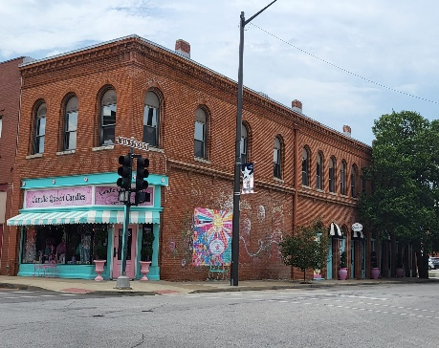**CANDLE QUEEN CANDLES**

**500 SHAWNEE, c. 1858**

This former saloon survives from Leavenworth’s early heyday and retains its historic features including a diagonal corner entry. The Fifth Street elevation has a continuous row of symmetrically placed, brick, arched opening on the first and second stories that incorporate windows and entrances. The original storefront elements on Shawnee Street (bulkhead, openings, transoms, and cast iron elements) are intact. Even the rebuilt chimneys retain their original configuration.

**NU WAY CAFÉ’**

**510 SHAWNEE STREET, c. 1942**

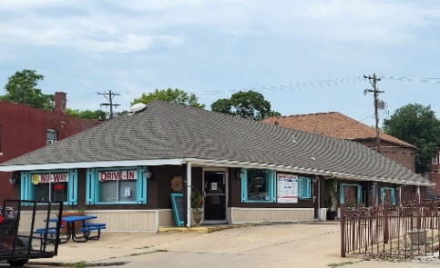

This is one of two surviving “Nu Way” drive-ins from the regional chain that dotted the south central states. It is significant for its auto-centric design as well as reflecting the evolution of commercial dining facilities in the District from saloon to restaurant/café to drive-in. The secondary facades have several openings of different sizes cut into them to accommodate a drive-through window and secondary entrances.

**CHAMBER OFFICE**

**516-518 SHAWNEE STREET, c. 1908**

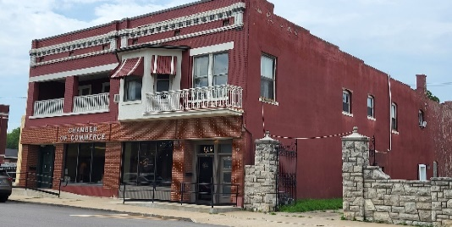

This two-story, red brick building has four bays. The first-story storefront is a modern alteration that retains the original configuration of entrances flanking two display windows. Wrought iron balconettes span the width of the upper floor windows. It houses the Chamber of Commerce and several shops, offices and residences.

**DAVIS FUNERAL CHAPEL**

**531 SHAWNEE STREET, c. 1867, c. 1930**

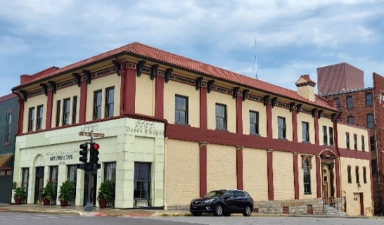Mediterranean Revivalinfluences of the early 20th century dominate this Carrara glass-front building. Flanking the two slightly recessed arched entrances are rectangular casement windows. Wrought iron fretwork decorates panels below these windows. The Sixth Street side features a classical door surround incorporating cast iron panels coupled with slightly recessed fluted columns resting on piers. Above the lintel is an elliptical arch with supporting brackets. The later application of Carrara glass panels has achieved significance as a historic alteration. The modern windows are reversible and do not detract from the building’s importance.

**LEAVENWORTH LOCAL HOTEL/IMMACULATA HIGH SCHOOL**

**600 SHAWNEE STREET, c. 1922**

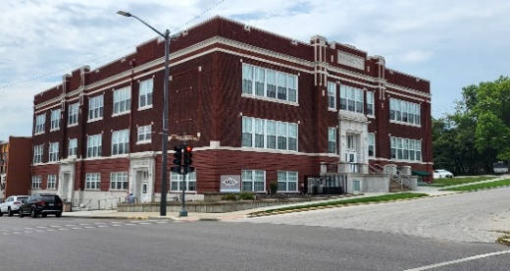“Imac” as it is known locally, bills itself as a college-preparatory school in an effort to attract students from Leavenworth’s government and military employment centers. Its downtown location provides an additional, largescale institution which strengthens the downtown’s stability. The structure references Art Deco motifs, and geometric terra cotta ornamentation creates “cuts” in the parapet walls for more definition. Upgrades have not spoiled the building’s high degree of original materials and architectural elements.

**BIRINGER’S**

**601 SHAWNEE STREET, c. 1864**

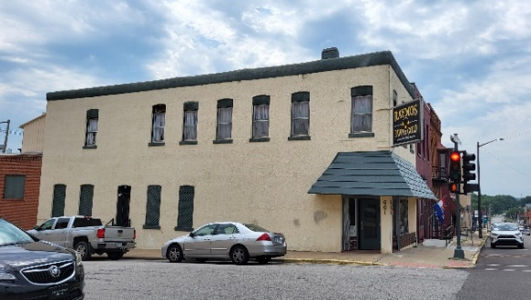Biringer’s, a locksmith and gunsmith, is one of the oldest continuous commercial operations in Kansas, dating to 1864 and has always been at this location. Originally starting as a gunsmith, the store still sells a wide variety of hunting gear but is heavily used by people who need locksmith services. Although this is a simple two-story stucco building with significant alteration, it retains its original size, scale, massing, fenestration, setting and location. The storefront retains its original configuration, and the original window and transom openings are in intact. It still communicates the commercial association it had with its period of construction.

**FORMER RESIDENCE**

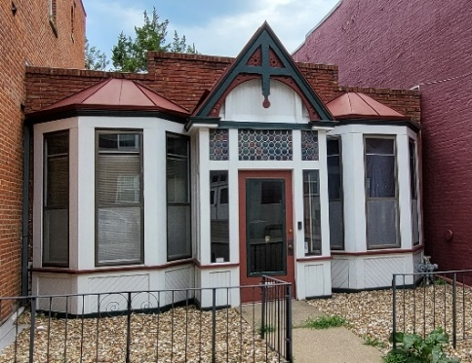**607 SHAWNEE STREET, c. 1883**

This small, one-story structure is recessed from the sidewalk. The central entrance bay has gable roof with cross bracing. The façade contains a central entrance flanked by projecting, three-sided bay windows applied to a brick building face. A copper hip roof caps the bays and the transom and the sidelights of polygonal lead windows. This building retains many of its architectural elements dating to the 1990s. Historic maps indicate a residence at this location prior to 1883. It is a unique component of the District and shows the mixture of land uses common to 19th century development.

**CITIZENS NATIONAL BANK**

**601 DELAWARE STREET, c. 1904**

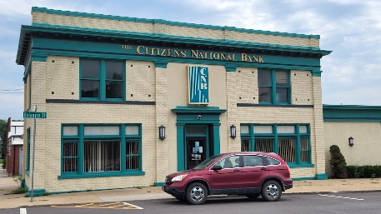

This symmetrical, two-story building has corner pilasters with stone capitals and bases that visually support and oversized entablature, cornice, and a stone-edged parapet. The entrance has fluted pilasters supporting a classical entablature. A wide entablature and a projecting cornice wrap around the building. Above this, a brick parapet with projecting, square, brick piers is directly above the pilasters. The building was the original sales office for the Lambert Lumber Company. Citizens National Bank is the only financial institution located in a historic property downtown.

**PEOPLE’S TELEPHONE CO.**

**529 DELAWARE STREET, c. 1906**

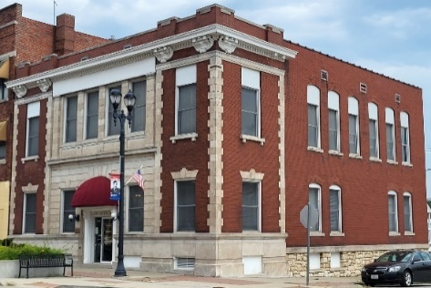

This corner building is a two-story structure with a brick and limestone façade that features symmetrical massing and classical ornamentation. The end bays of the primary façade are composed of red brick flanked by stone quoins. The first-story windows have stone lintels with keystones. The central portion of the building has smooth limestone facing. The building was built for the People’s Telephone Company, was converted to an outpatient hospital in the 1970s, and is currently occupied by a law office.

**WARDS BUILDING**

**528 DELAWARE STREET, c. 1908**

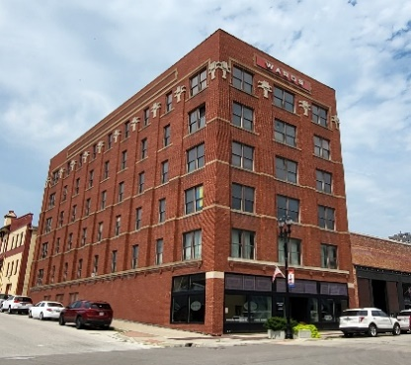

This is the only remaining six-story commercial building in the downtown. There is a three-bay front (south) elevation and a nine-bay side (west) each separated by brick pilasters that terminate midway at the sixth story with geometric, stone capitals. It was built for a tin or steel fabricator and warehouse, and was converted to the Montgomery Ward Department store. In the intervening years, it has been a furniture, antique and collectibles hop. In 2003, the building was purchased and will be converted to an e-business office complex that is projected to employ over 100 computer technicians by 2010.

**SADTK’S FURNITURE STORE**

**523 DELAWARE STREET, c. 1915**

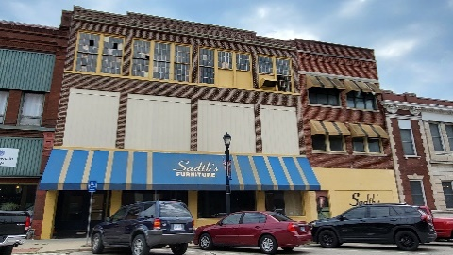Although infill covers the original first-story storefront, the original second-and-third-story windows continue to be important character-defining elements of the building and its mass and style contribute greatly to the district.

**COLONIAL REVIVAL**

**520-522 DELAWARE STREET, c. 1903**

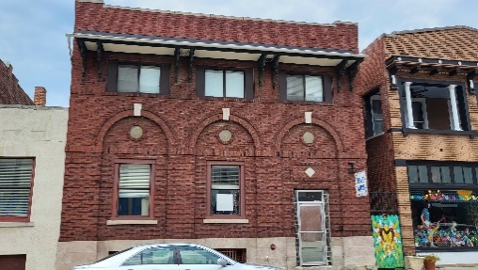Ornamented cast iron brackets highlight this Colonial revival structure. Other stylistic elements include three molded, semi-circular, brick arches with key-stones, roundels centered within each arch under a shed roof supported by paired ornamented cast iron brackets. These details, combined with the Colonia revival motif, reflect an eclectic assembly of features that are each historic to their construction era. The building has been used as a bank, a credit bureau and for associated offices.

**FIRST CITY DANCE**

**521 DELAWARE STREET, c. 1905**

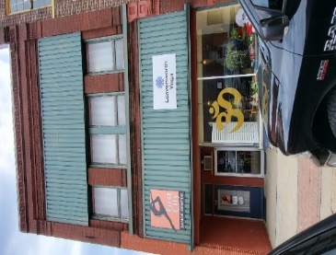These buildings contribute because of their mass (523 & 521 Delaware), but otherwise have almost no ornamentation. The oversized windows rise into an area that normally would incorporate a third story. The treatment of the second story is consistent with its former use as a meeting hall. The window openings, transoms and casements are intact under the metal sheathing.

**TOP ORIGINAL WINDOWS**

**512-514 DELAWARE STREET, c. 1890**

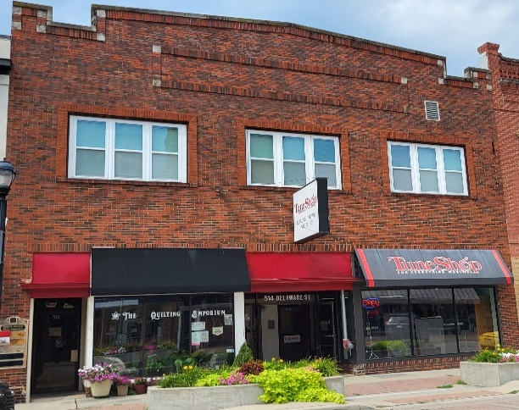

As with 521-523 Delaware, these storefronts offer little architectural appeal, but they retain their original windows, door and transom configuration and contribute to the district by their mass.

**NEW HOPE ASSEMBLY OF GOD**

**513 DELAWARE STREET, c. 1899**

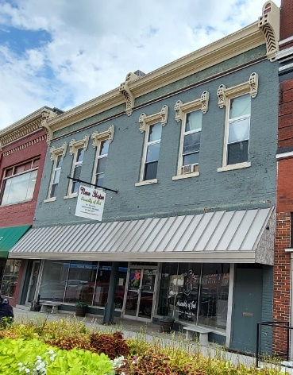

Despite storefront and window insert alterations; this building retains much of its original building material, ornamentation and Classical Revival stylistic idioms. It conveys clear associations with its period of construction and with its original commercial and organizational use. It retains all of the window openings, stringcourses, attached columns and cornice-all of which are dominant design features. The transom window appears to be intact under paneling. The inappropriate infill can be easily reversed without damaging the buildings materials.

**QUEENS TEA**

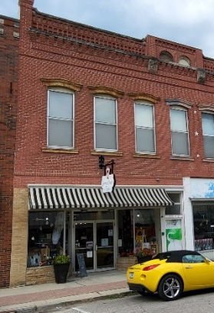**510 DELAWARE STREET, c. 1890**

this two-story, brick building has an ornate brick cornice with two arched openings surrounded by brick voussoirs and projecting pilasters resting on rounded stone bases The first story of the building incorporates two storefronts, both of which reflect sensitive alterations and retain their original configuration.

**BEAUTY SUPPLY STORE**

**509 DELAWARE STREET, c. 1890**

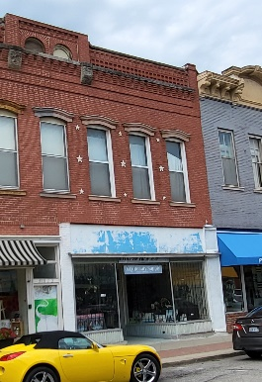

This two-story, painted-brick building exhibits Italianate features commonly found in commercial buildings of the late 19th century. Those defining elements include the extruded and bracketed cornice, exaggerated bracketed window hoods, and the symmetrical arrangement of the fenestration. Doors providing access to the second story are on either side of the double storefront, in the end bays. The rectangular windows have stone sills and window hoods with exaggerated, stylized brackets. Despite the alteration to the storefront and the exterior paint, this building retains its original storefront material and character-defining architectural elements.

**LEAVENWORTH ANTIQUE MALL**

**505-507 DELAWARE STREET, c. 1922**

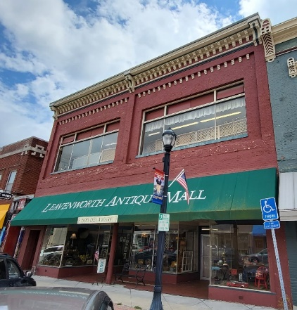

This painted brick building maintains its historic integrity through the retention of the original configuration of its storefronts, the dominant, second-story window treatment, the upper façade’s original brickwork, stringcourses an the elaborate cornice.

**DOUBLE D BARBER SHOP and PLAIN JANES QUILT SHOP**

**504-506 DELAWARE STREET, c. 1883**

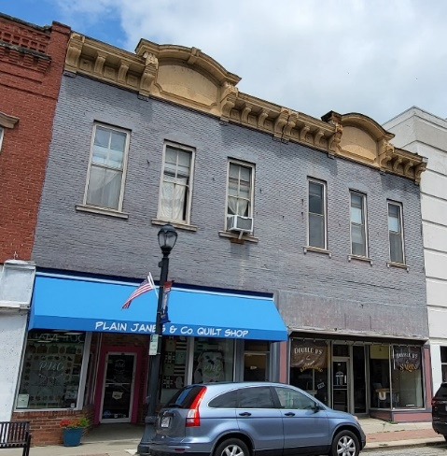

This building’s roofline is dominated by a heavy, elaborately decorated entablature and cornice. The cornice design employs a central gable front dormer for each storefront section, flanked by a projecting cornice supported by scroll brackets. This building retains a sizable portion of its original ornamentation, fenestration, materials and design.

**FIRST CITY CREATIVES**

**501-503 DELAWARE STREET, c. 1938**

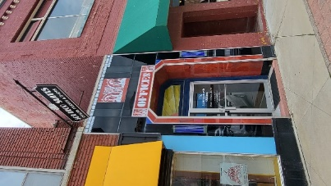

Several geometric forms provide the design motif of this structure. Original elements include a recessed corner entry and continuous display windows. The most distinguishing characteristic is the 1938, Art Deco red Carrara glass panels aside a one-story bay that services the upstairs offices. The building is representative of streamlined 20th century designs of the 1920s and 1930s.

**HOLLYWOOD THEATRE**

**500 DELAWARE STREET, c. 1937**

**NATIONAL REGISTER PROPERTY 1989**

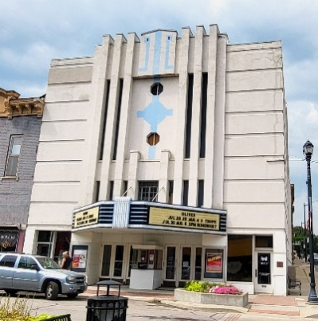

This two-and-one-half-story, concrete building represents the Art Deco architectural style of the 1920s-1930s. The central vertical definition on the building’s symmetrical south elevation emphasizes the marquee-entry area. The marquee shelters two recessed entries and the ticket booth. The City Seal was painted in the recessed circle which was originally painted pink and green. Small shop areas on either side have recessed entries and display windows. This is used as the city’s Performing Arts Center and is one of a handful of art deco theaters left in the state. It was placed on the Kansas Register of Historic Places in 1985 and had to wait two years before it was qualified for submission to the National register. This is one of only two buildings downtown that were on the National Register prior to submission of the district.

**KARMA CAKES**

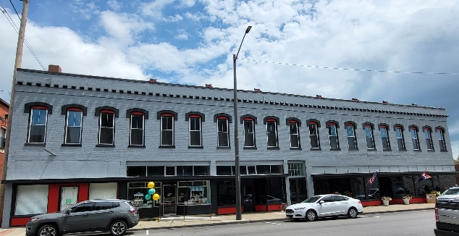**213-223 S FIFTH STREET, c. 1880**

The building’s primary façade faces west and contains five storefronts. It has been covered with tin siding for over 30 years. In 2001, a storm tore off pieces of the metal exterior siding creating a public safety hazard. The property owners initially sought to replace the metal with a seamless aluminum siding, but the local landmarks board successfully negotiated a tuckpoint and painting alternative, which the owners accepted…and saved almost $50,000 in cost differential when local tax incentives and grants were factored into the price. The building contributes to the district more so because of its mass than its detail.

**CJ GIFT CO.**

**430 DELAWARE STREET, c. 1921**

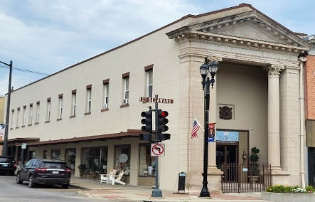

This two-story commercial building with a temple front, gray Indiana limestone and Neo-Classical features corner piers with classical detailing and columns with Corinthian capitals and low, square plinths support a wide entablature and pediment. This design of the pediment incorporates dentils. Wrought iron fencing inhibits passage to the centralized entry.

**CORNER PHARMACY**

**429 DELAWARE STREET, c. 1905**

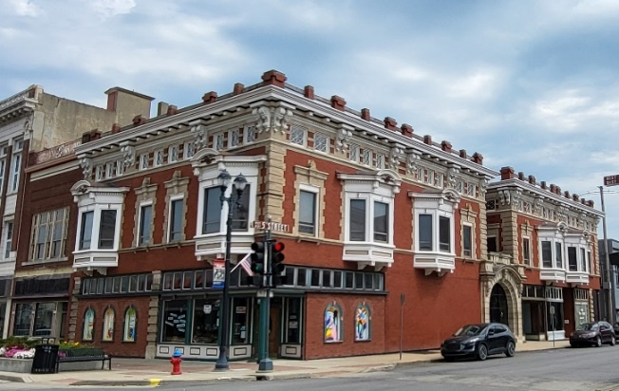This two-and-one-half-story, symmetrically massed, red-an-tan brick building has an eclectic combination of stylistic ornamentation, and Classical terra-cotta ornamentation decorates the wide arch surrounding the main west side entrance. Upper elevation windows are slanted bays with bracketed, arched hoods, or are rectangular openings with contrasting brick surrounds and cornices with elaborate keystones. Contrasting brick also creates quoins on all of the building’s corners. The upper half story forms an entablature punctuated by regular spaced windows between paired scroll brackets that support a molded cornice. Dentils follow the upper line of the entablature. This is Leavenworth’s fanciest downtown building and currently houses Mom’s Treasures.

**REVIVAL & COLONIA REVIVAL**

**427 DELAWARE STREET, c. 1905**

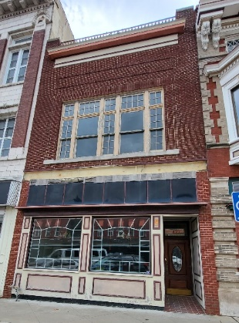

This two-story, symmetrical, dark-red brick building is an example of early 20th century Revival and Colonia Revival design idioms. On the classically designed upper façade, brick piers frame a single bay and extend above the parapet to form posts for a wrought iron balustrade. A wide entablature and decorative cornice complete the elevations design. Despite modern renovation, the building’s mass is important to the district.

**MASONIC BUILDING**

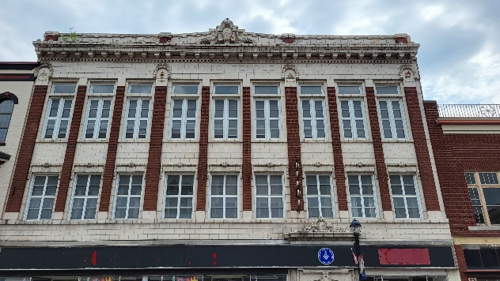**421-423 DELAWARE STREET, c. 1914**

This three-story, symmetrical brick building has classical terra-cotta ornamentation. The storefront housed F.W. Woolworth Co. and features a recessed entry with classical ornamented surrounds. The Masonic Block includes another small shop with a recessed entry. Brick pillars separate the upper story bays. The brick pillars and the spandrels below the windows have terra-cotta tiles. A dentil course, brackets, and elaborate molded cornice, and ornamented parapet cap the building. This property has retained its architectural elements representative f period style with a high degree of integrity.

**DADS TOYS**

**417 DELAWARE STREET, c. 1870**

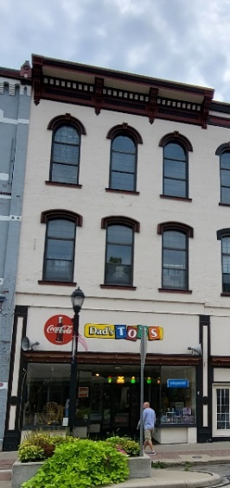

This three-story, three bay, symmetrical-painted brick building exhibits Italianate ornamentation above its remodeled storefront. A 1930 alteration changed the original storefront configuration to a deeply recessed entry flanked by display windows. A temporary panel runs above the storefront openings to the sills of the second-story windows covering the transom area. The third story windows have a full arch and the arched window hoods have keystones. The building terminates with a paneled entablature, elaborate brackets, corbelling and a projecting molded cornice. With the exception of some minor storefront alterations, the building retains a high degree of integrity.

**REUNIONS ANTIQUES**

**414 DELAWARE STREET, c. 1940**

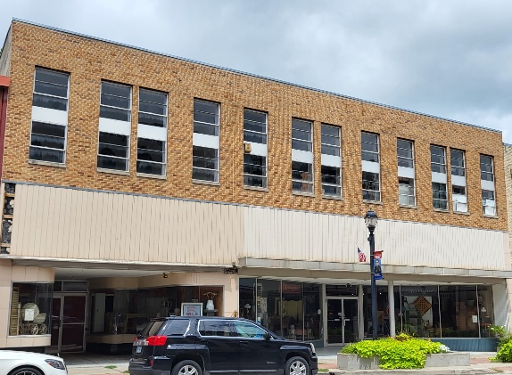

This two-story, buff-brick building contains a grouping of four, tall, aluminum, stacked vent awning windows. The first story is comprised of storefront windows. The west section retains its original, curved glass recessed storefront surrounded by Carrara glass

**OUT OF THE BARN**

**409-413 DELAWARE STREET, c. 1900**

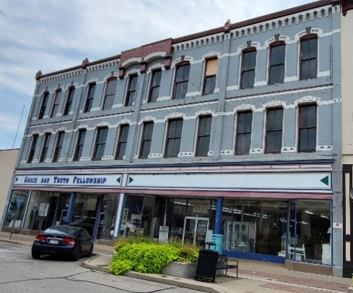

This three-story building lost its original cast-iron window hoods; a recent restoration replicated them in paint. The two-over-two light, double-hung sash windows are original. Applied brick pilasters rise past the cornice to a finial. Signage panels cover the original transom windows. The modern storefronts retain the original cast iron posts. This building Compliments the Masonic block.

**MILITARY GIFT SHOP - 412 and OVERLOOKED ANTIQUES - 408**

**412 & 408 DELAWARE STREET. c. 1910**

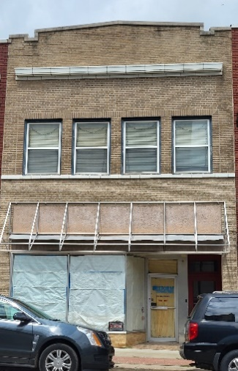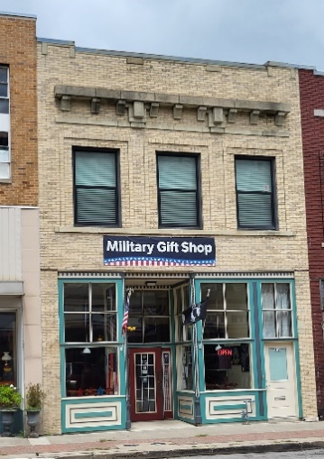These two-story, buff-brick buildings have been modernized with wood panels over the original transoms and aluminum and glass storefronts and canopy style awnings. The retained, original architectural elements are sufficient to communicate the building’s original design, feelings and associations despite the 1980s renovations. Twenty years from now, they might qualify as historic to the era, but the modernizations efforts are reversible.

**THE ESCAPE GAME – 400 and ALIGNED HEALTH CHIROPRACTIC - 402**

**400-402 DELAWARE STREET, c. 1860, c. 1905**

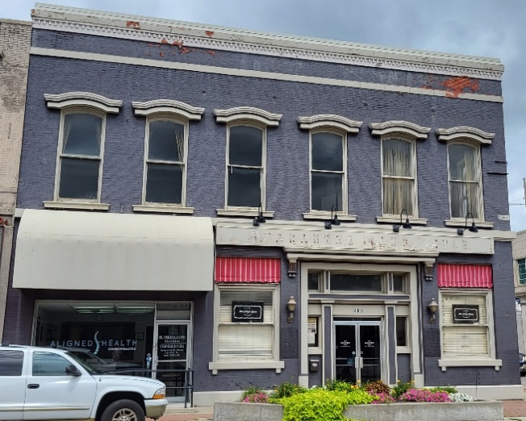This two-story building is one of the downtown’s original grand commercial properties. It once housed Russell, Majors and Waddell, the outfitters who later became the postal contractor that created the Pony Express (albeit in St. Joseph, Missouri). Prior to its use as a title company, it was the Manufacturers State Bank (Commerce Bank today). The primary facade (south) ground floor has two entrances. The eastern entrance contains a 1905 Colonial Revival style entry. The eastern entry is a modern storefront. The fenestration and ornamentation on the east elevation (Fourth Street) is similar to that of the south elevation. The early 20th century remodeled (eastern) storefront represents a historical “modernization” characteristic of retail commercial centers at the turn-of –the-century. Despite the replacement of some of the window sashes, this building retains a high degree of architectural integrity.

**SERENITY HAIR DESIGN to WILLCOTT BREWING**

**600 BLOCK CHEROKEE STREET, c. 1880s**

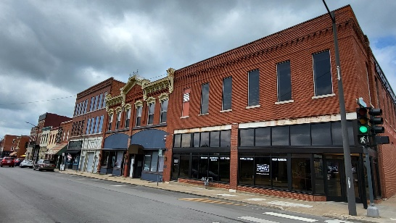

The 600 Block of Cherokee Street was included in this district because the center structures (604-612) are intact 1880s block of buildings. The carnival style, Spanish Colonial gas station on the west end of the block is a 1930s infill, a style that is vanishing from the country’s landscape. Although this was probably not the first gas station build to serve motorists, it is the oldest remaining such structure from that early era.

**ITALIANATE ORNAMENTATION BUILDING**

**604-606 CHEROKEE STREET, c. 1887**

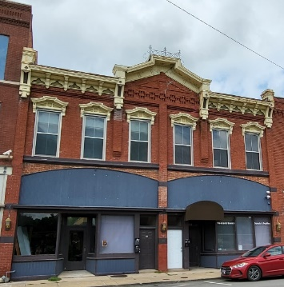

The Oasis Café is currently idle but the owner restored the building for the restaurant with apartments on the upper level. This two-story, symmetrically massed, red-brick commercial block has elaborate Italianate ornamentation and multiple storefront bays. Huge brackets support the cornice and hood all of the important character defining architectural features and ornamentation remain. Originally constructed as the Cleverdon Drug Company, the building has also housed the BPOEOW, known locally as the Black Elks, before its conversion to a restaurant in the early 1990s.

**SIS’ SWEETS - 610**

**610-614 CHEROKEE STREET, c.1890**

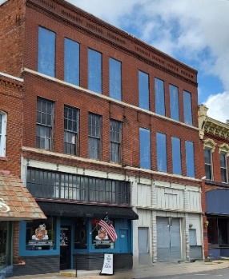

The size, scale, massing, much of the original material, setting and association with their era help these two buildings contribute to the district.

**SERENITY HAIR DESIGN**

**630 CHEROKEE STREET, c. 1934**

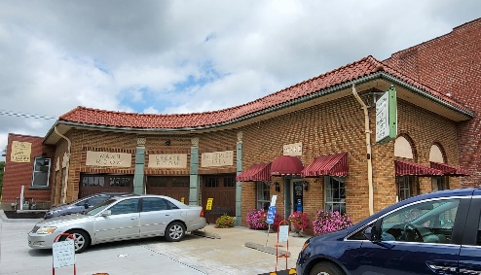

This one-story, asymmetrically massed, brick curved “L” plan building is on a corner lot at 7th and Cherokee Streets. It is one of the few surviving examples of the “carnival” style of early auto-service stations. Terra-cotta pilasters topped with urn-shaped ornamentation separate the three service bays. The south end wall has arched, recessed garage door entrances with overhead, incised lettering detailing the gas station services offered. This property has had no exterior alterations over time.

**MERIWEATHERS**

**700 CHEROKEE STREET, c. 1865**

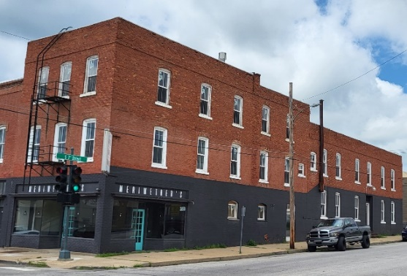

Originally built as a grocery store, this three-story brick building was also the Burlington Hotel and it recently reopened as the Market Place Bakery. It is one of a handful of three-story buildings remaining in the Central Business District, and it is one of the original downtown buildings.

**RED-BRICK BLDG**

**702 CHEROKEE STREET, c. 1875**

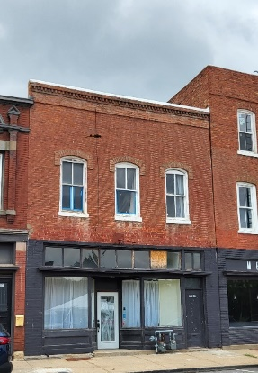

This two-story, red-brick building reflects popular late 19th century commercial design idioms. A wood-frame storefront within the façade’s brick framework also features iron storefront posts. On the second story, slightly arched, four-over-four light, double-hung sash windows have stone sills and soldier course brick “hoods.” Brick stringcourses and dentils decorate the parapet wall. This building retains sufficient integrity to be a contributing resource to the District.

**SOUL SUPPLY & HARDWARE**

**704 CHEROKEE STREET, c. 1897**

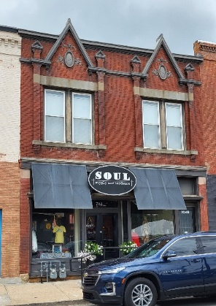

This two-story, brick commercial building features Jacobethan Revival-style details – steeply pitched parapet-front gables, polychrome coat of arms ornamentation in the gables flanked by vertical pilasters, cast stone trim and tall, narrow, paired windows. Suspended brick pilasters pierce a stone cornice and terminate just below the roofline with small stone pediments. Centered above each paired window opening are two gable dormers that protect above the roofline. Originally Ressmeyer’s Grocery, it is presently owned by a retail import business.

**INSLEY HOUSE & OUTBUILDINGS (Red Brick Home)**

**602 SENECA STREET, c. 1860**

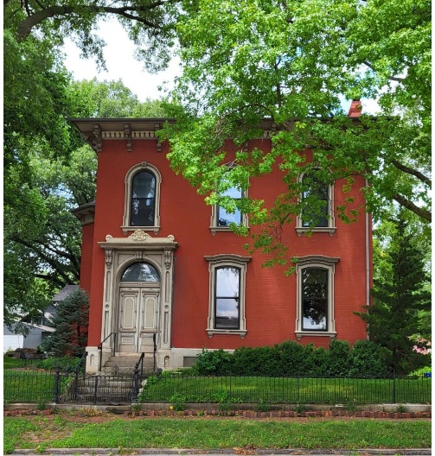

The original brick structure at this location was built in the late 1850s. Major additions were made to the house in 1865-1866. Quite possibly, many of the materials used were left over from the construction of the impressive Thomas C. Stevens home on South Esplanade, which occupied the grounds between Arch and Vine Streets. In 1883, interior changes were made to accommodate plumbing, for this was the first year it was available in the city. The home evolved into an Italianate style, and it is probably the best surviving example in Leavenworth of this type of architecture.

The Insley House has solid brick interior walls, which are substantial for an early building. It is a two-story structure with a stone foundation and a truncated hip roof. The home faces south and has three bays, and an arched doorway contains an etched glass transom with the address number. The frame porch on the east is of Italianate design. Side lights and a transom surround the door on the east side, which was the main entrance until the 1866 alterations. All windows from the molded surrounds, semi-circular arched hood and keystones while the first story windows have molded surrounds and segmental arch hoods. An 1883 fountain built on the northeast corner of the property no longer exists, although the original c. 1866 brick outhouse is north of the property on the alley. West of the home and to the rear of the property is a c 1874-1875 carriage house. Brick sidewalks and a wrought iron fence surround the property on the east and south sides. In 1863 entrepreneur and banker John Kerr bought the house for $1500 and he completed the major addition to the home in 1866. Later that year, Merritt H. Insley, an entrepreneur and financier in town, bought the property for $20,000. Captain Insley was a partner in the banking firm of Insley, Shire and Company, and treasure of the Missouri River Bridge Company and the Leavenworth Cattle Company. In 1894 Insley’s investments turned sour in the depressed economic climate in the late 19th century, and he sold the property.

**ATCHISON, TOPEKA & SANTA FE**

**RAILROAD PASSENGER DEPOT**

**(THE DEPOT RESTAURANT)**

**781 SHAWNEE STREET, c. 1887**

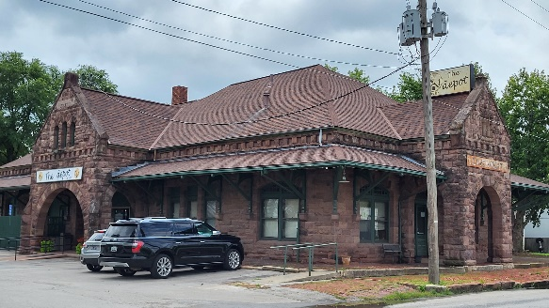

This structure was built in 1887 as a passenger and freight depot, possibly by J.A. McGonigle, a prominent Leavenworth builder. It was located west of the city’s central business district, and near the north-south lines built in the 1870s for the Leavenworth, Lawrence and Galveston Railroad Company. It served as a passenger depot for the Atchison, Topeka and Santa Fe and as a station for the Fort Leavenworth/Kansas City Interurban Railway until the early 1930s. It was then converted to a freight deport, and an addition on the south elevation was constructed at the time.

The architectural style of this pink sandstone building is Richardsonian Romanesque. It is 1 ½ stories tall, and is located on the east side of two pairs of tracks. The primary façade faces west and has a circular bay with a conical roof, which was a room for the station master. The hip roof has three gable projections, which on the north and east sides shelter entry arcades. On the interior, separate waiting rooms were built for men and women.

The depot is culturally significant, and maintains a high degree of integrity. The original configuration and architectural elements remain intact. In 9182 it eased operation as a freight depot and was bought by a private investor. The depot has been used since then primarily as a restaurant. In 1986, it was added to the National Register of Historic places.

Updated 8/4/2023